An insulin pump control system  
An insulin pump is a medical system that simulates the operation of the pancreas (an internal organ). The software controlling this system is an embedded system, which collects information from a sensor and controls a pump that delivers a controlled dose of insulin to a user.  
People who suffer from diabetes use the system. Diabetes is a relatively common condition where the human pancreas is unable to produce sufficient quantities of a hormone called insulin. Insulin metabolises glucose (sugar) in the blood. The conventional treatment of diabetes involves regular injections of genetically engineered  
insulin. Diabetics measure their blood sugar levels using an external meter and then calculate the dose of insulin that they should inject.  
The problem with this treatment is that the level of insulin required does not just depend on the blood glucose level but also on the time of the last insulin injection. This can lead to very low levels of blood glucose (if there is too much insulin) or very high levels of blood sugar (if there is too little insulin). Low blood glucose is, in the short term, a more serious condition as it can result in temporary brain malfunctioning and, ultimately, unconsciousness and death. In the long term, however, continual high levels of blood glucose can lead to eye damage, kidney damage, and heart problems.  
Current advances in developing miniaturized sensors have meant that it is now possible to develop automated insulin delivery systems. These systems monitor blood sugar levels and deliver an appropriate dose of insulin when required. Insulin delivery systems like this already exist for the treatment of hospital patients. In the future, it may be possible for many diabetics to have such systems permanently attached to their bodies.  
A software-controlled insulin delivery system might work by using a microsensor embedded in the patient to measure some blood parameter that is proportional to the sugar level. This is then sent to the pump controller. This controller computes the sugar level and the amount of insulin that is needed. It then sends signals to a  
miniaturized pump to deliver the insulin via a permanently attached needle.

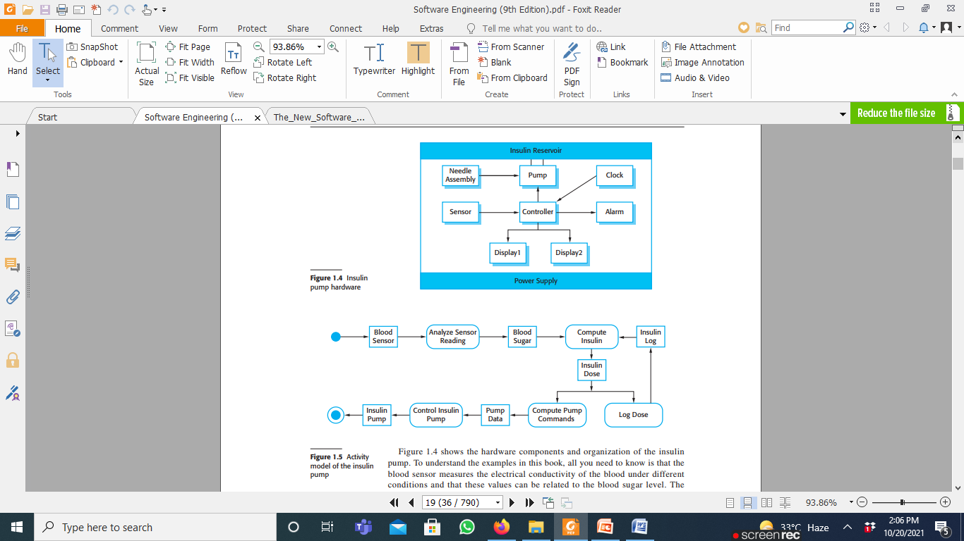

Figure 1.4 shows the hardware components and organization of the insulin pump. To understand the examples in this book, all you need to know is that the blood sensor measures the electrical conductivity of the blood under different conditions and that these values can be related to the blood sugar level. The insulin pump delivers one unit of insulin in response to a single pulse from a controller. Therefore, to deliver 10 units of insulin, the controller sends 10 pulses to the pump.

Figure 1.5 is a UML activity model that illustrates how the software transforms an input blood sugar level to a sequence of commands that drive the insulin pump.  
Clearly, this is a safety-critical system. If the pump fails to operate or does not operate correctly, then the user’s health may be damaged or they may fall into a coma because their blood sugar levels are too high or too low. There are, therefore, two essential high-level requirements that this system must meet:  
1. The system shall be available to deliver insulin when required.  
2. The system shall perform reliably and deliver the correct amount of insulin to  
counteract the current level of blood sugar.